 |  |  | June 2022 Room 22
Phys. Ed: Days 1, 2, 3, 4, 5 Music: Days 1, 3, 4 ,6
Library: Day 6

Sunday | Monday | Tuesday |  | Wednesday | Thursday | Friday | Saturday
 |  |  |  | 1 Day 4 | 2 Day 5  Lower  Fort Garry  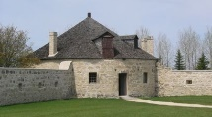 | 3 Day 6  Inservice Day | 4
5 | 6 Day 1  Hot Lunch (Smoothie) | 7 Day 2 |  | 8 Day 3  Gr. 4 Soccer Tournament  (Morning only)  Gr. 5’s stay at school with grade 5 classes | 9 Day 4  Hot Lunch | 10 Day 5 | 11
12 | 13 Day 6  Our Last Library Class | 14 Day 1 |  | 15 Day 2  Gr. 4  Soccer  Rain date | 16 Day 3  W.I.S.E.  Rocks and Minerals Presentation | 17 Day 4 | 18
19 | 20 Day 5  Gr. 5  Track & Field  (All Day)  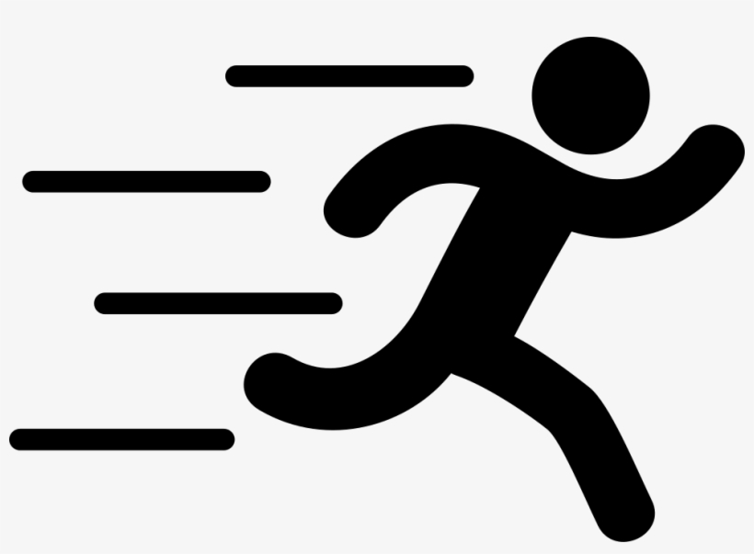  Gr. 4’s stay at school with grade 4 classes | 21 Day 6  Happy Birthday Rowan! |  | 22 Day 1  Gr. 5  Track & Field  Rain date | 23 Day 2  Legislative  Field Trip | 24 Day 3  Tabloid Day | 25
26 | 27 Day 4  Tabloid Day  Rain date | 28 Day 5 |  | 29 Day 6  Last Day of School | 30 Day 1  Inservice Day | Happy July Birthdays to:  Jivat 11  Alyvia 24  Dominic 27  Madilyn 27 | Happy August Birthdays to:  Zach 17  Yoddha 31

What’s Happening in Room 22?

To: Parents/ Guardians
From: Mrs. Dewar / bdewar@lssd.ca / www.mrsdewar.weebly.com

During June, the following topics will be covered in our classroom. Please feel free to contact me if you have any questions.

English Language Arts
- Review of Reading Powers & Novel Study
- Quick Writes
- Handwriting
- Home Reading – Please continue to read at home at least 20 - 30 minutes each day!

Mathematics
- Continued practice of multiplication and division facts
- Ninja Math – complete division
- Decimals
- Division
- Solving Word Problems using Division

Social Studies
- New France

Science
- Maintaining a Healthy Body- final project
- Rocks and Minerals

Other
- Please return all of Mrs. Dewar’s books. Check bookcases and rooms and return these beloved books for others to cherish next year. Thank you!

